**Backtracking**

Task-1. Implement N Queen's problem using Back Tracking.

**Instructions**: Your task is to develop a program for solving N-Queen problem using backtracking. Hence N should be read from the file “queen.txt”. The following are the sample input and output

Sample input:

4

Sample output:

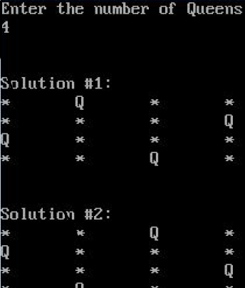

Note: Your input file should contain more than 5 input cases and you have to show at least two solutions for each test case. Finally draw a graph of number of trials vs number of queens.